Computer Science 455 Project 1

By Justin Carlson

Case 1:

The first case of this project was to implement fragmenting. The network of nodes properly disperses as is characteristic of fragmenting. From the time intervals below we can see the network gradually spread out and become less connected.

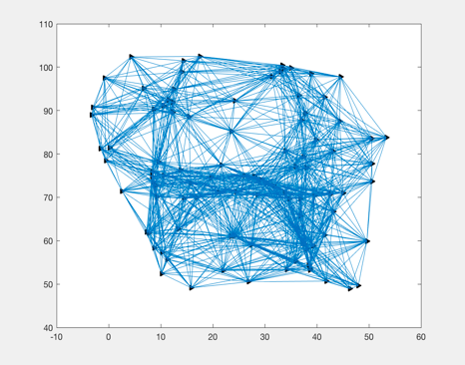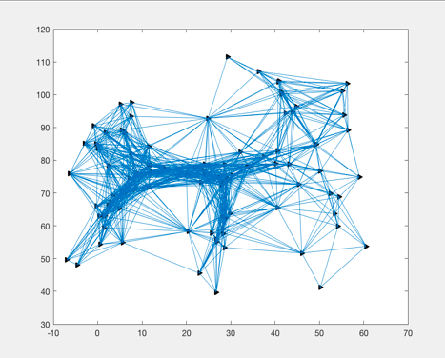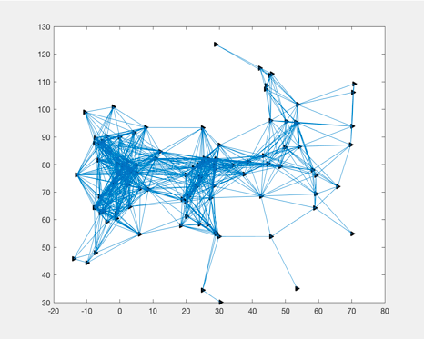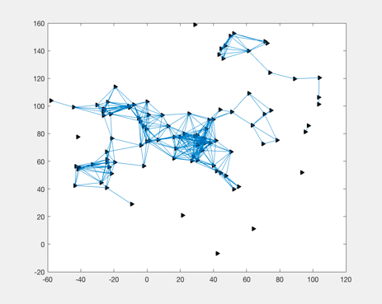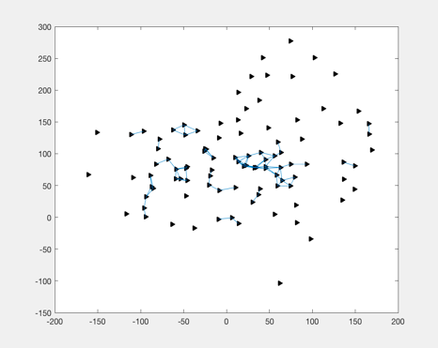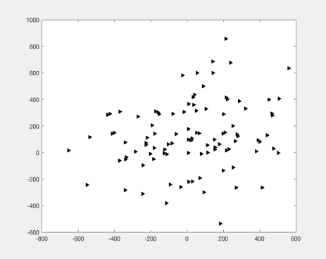

We can also see the trajectories, velocities, and connectivity respectively in the screenshots below:

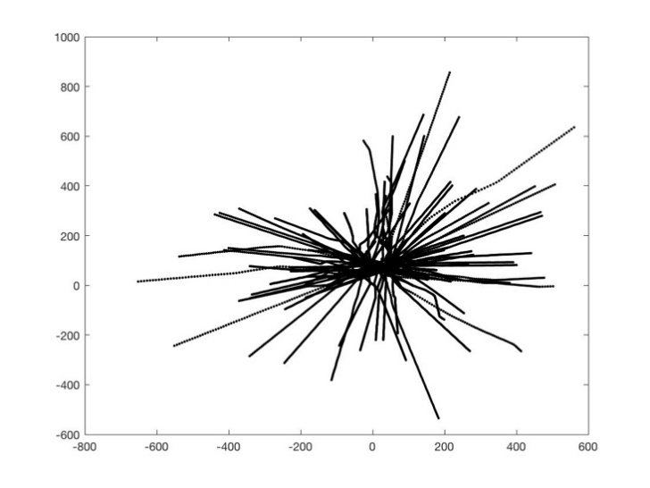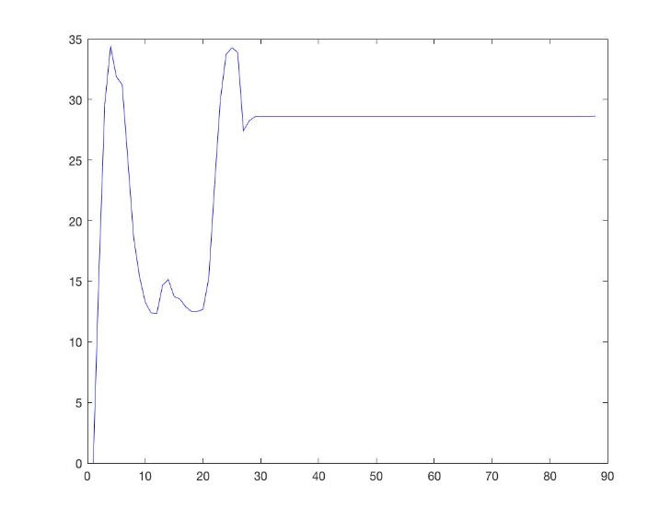

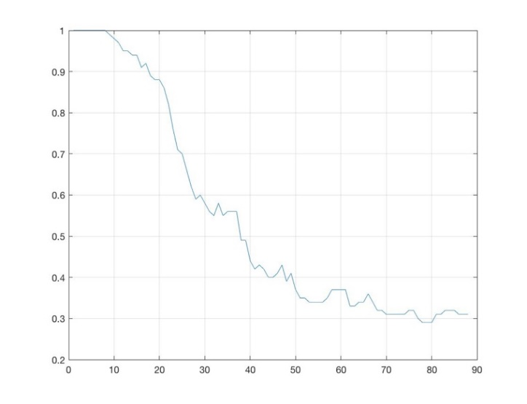

Figure 1.4: Connectivity of Graph

Case 2:

For case 2, we were to implement flocking towards a static gamma target using a more advanced acceleration controller. This gamma target, highlighted in red, is at a position to the upper right of the graph. In the screen shots below we can see the network progressively move towards the gamma target.

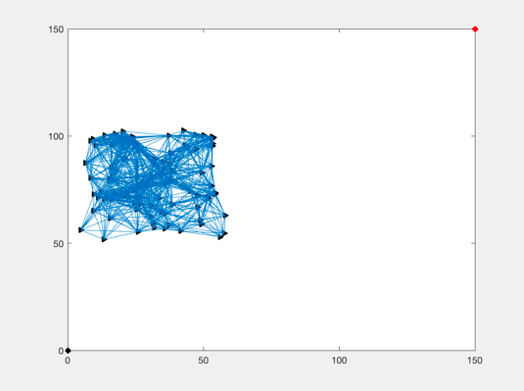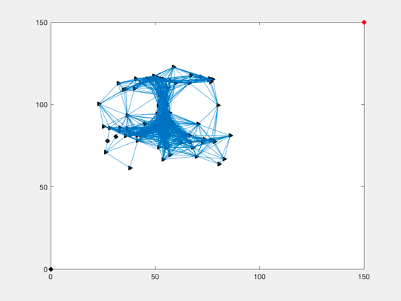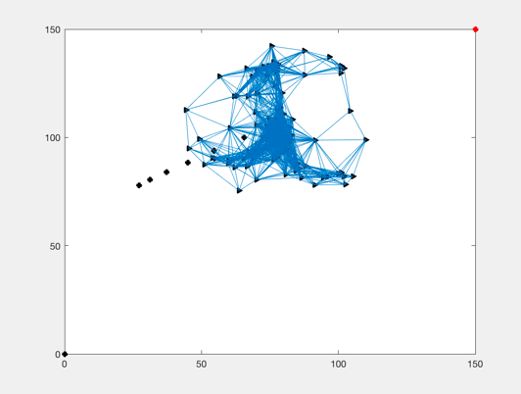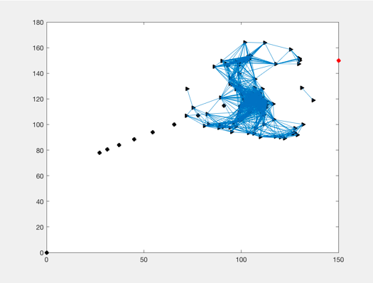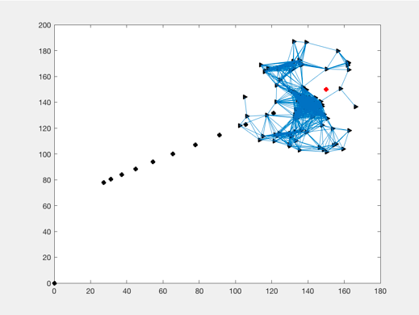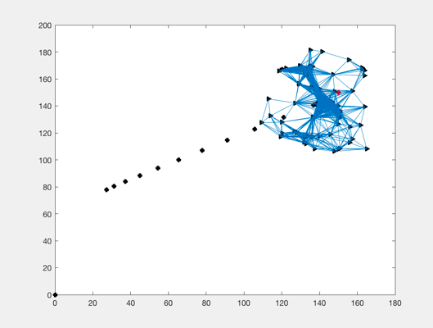

Below we can see a more in-depth technical analysis of the trajectory, velocity, and connectively respectively in the screenshots below:

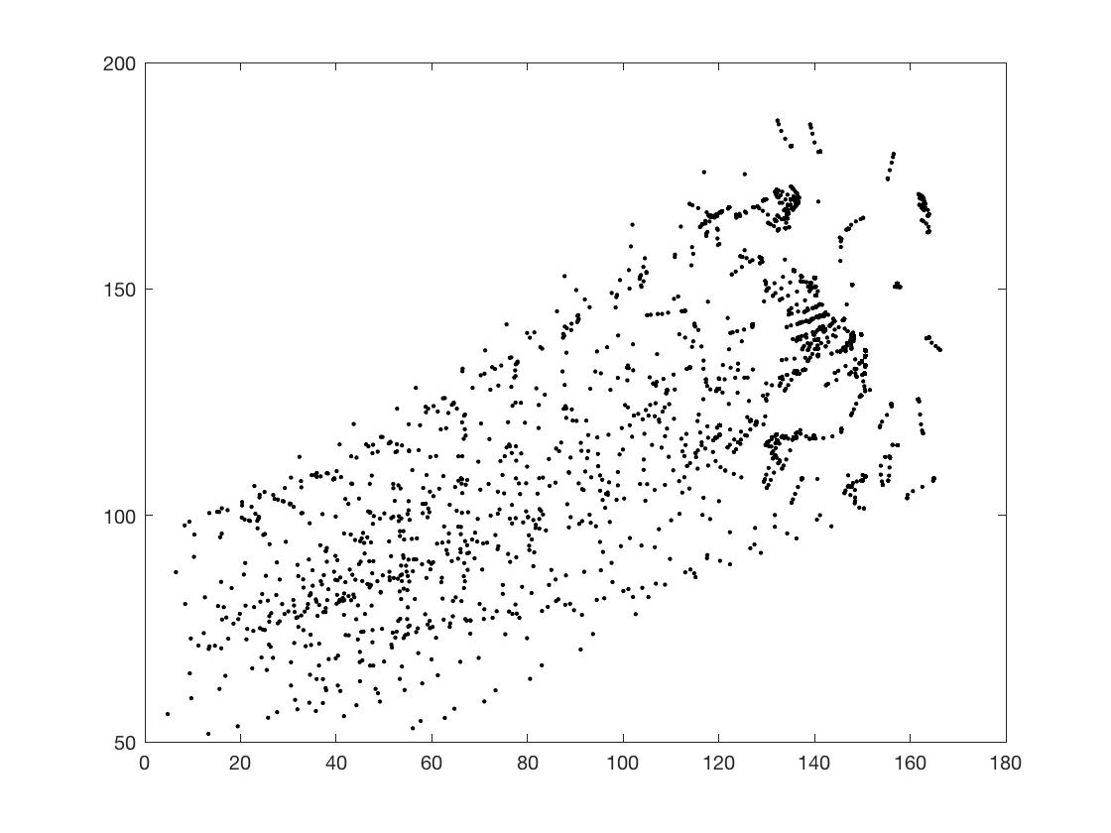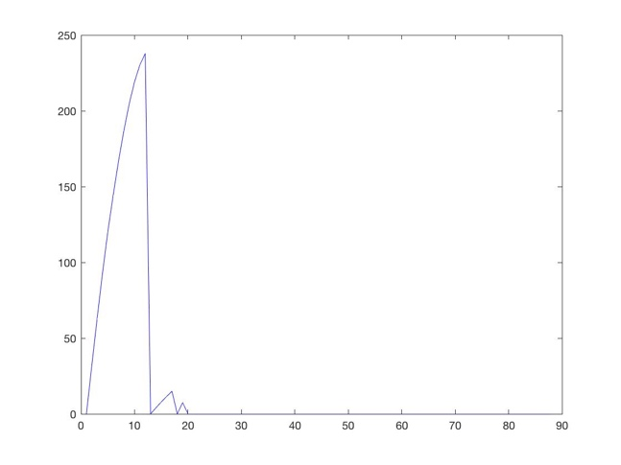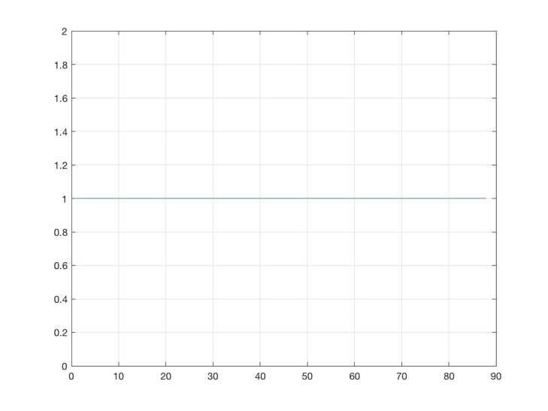

Case 3:

For case 3, we were to implement flocking towards a dynamically moving gamma target. This target would move in the formation of a sine wave. This would require a slightly tweak velocity controller. We can see in the succession below that the network tracks and flocks around the gamma agent as it progresses through space.

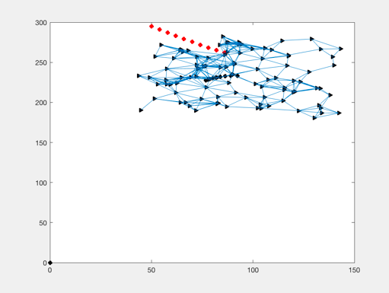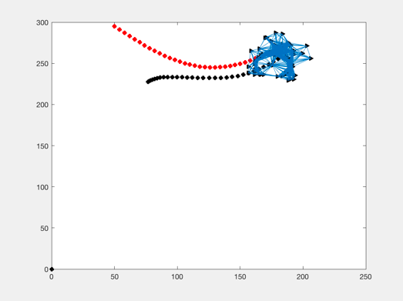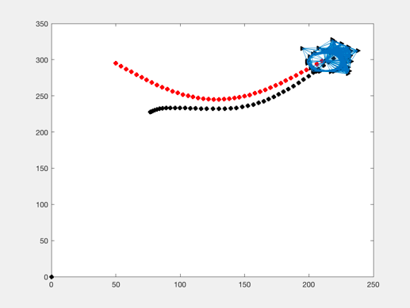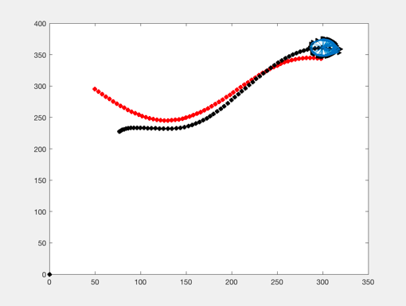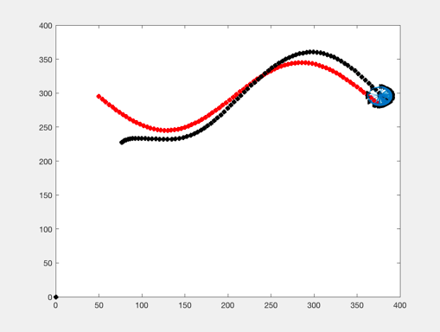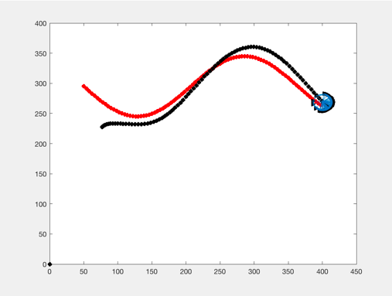

Below we can see a more in-depth technical analysis of the trajectory, velocity, and connectively respectively in the screenshots below:

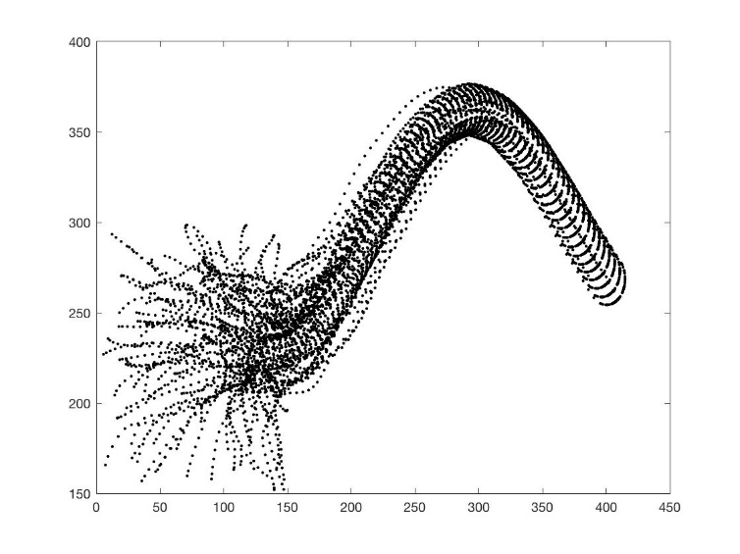

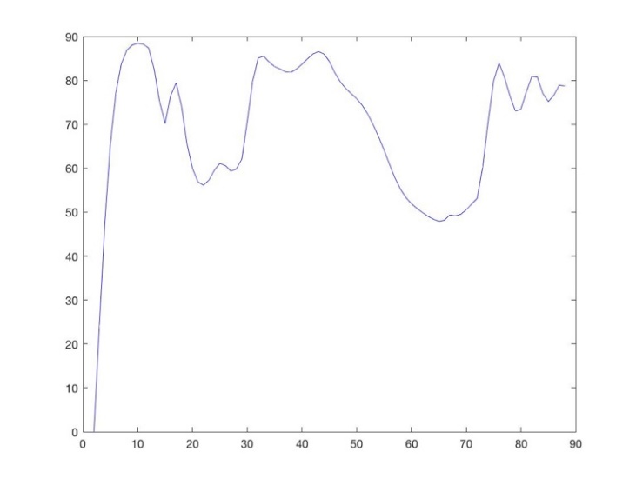

Figure 3.3: The velocities of the flock

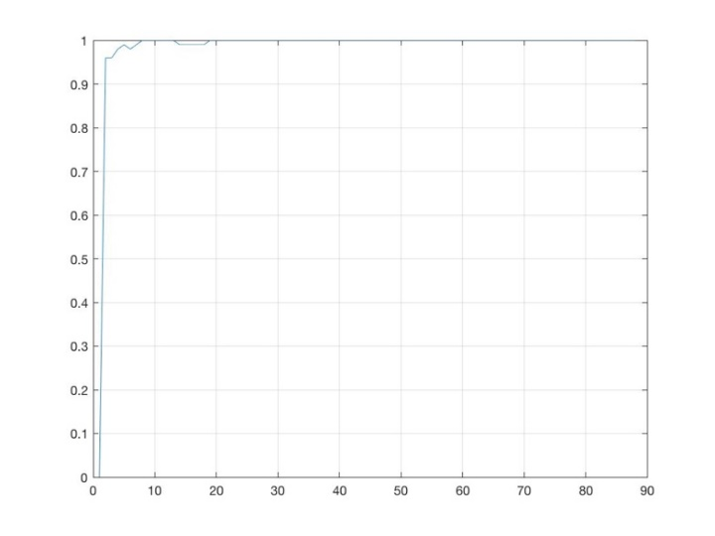

Case 4:

For case 4, we were to implement the same thing as Case 3, but instead of a gamma target that follows a sine wave, the gamma target would follow a circular path. This uses the same velocity controller for the network but a different one for the gamma target. We can see in the succession below that the network tracks and flocks around the gamma agent as it progresses through space.

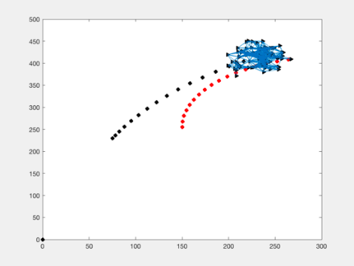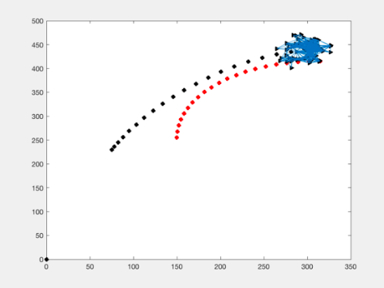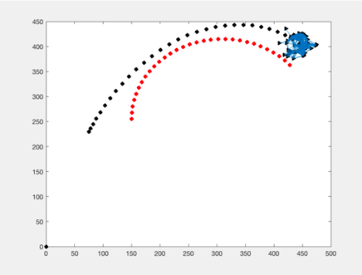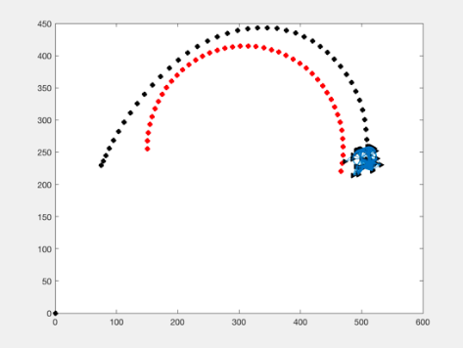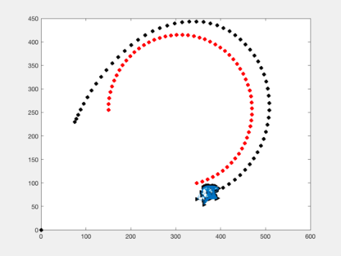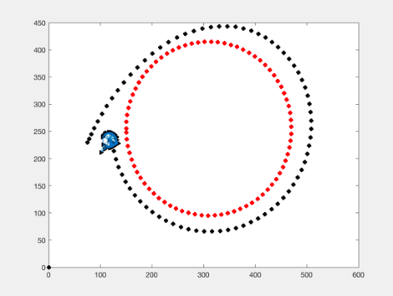

Below we can see a more in-depth technical analysis of the trajectory, velocity, and connectively respectively in the screenshots below:

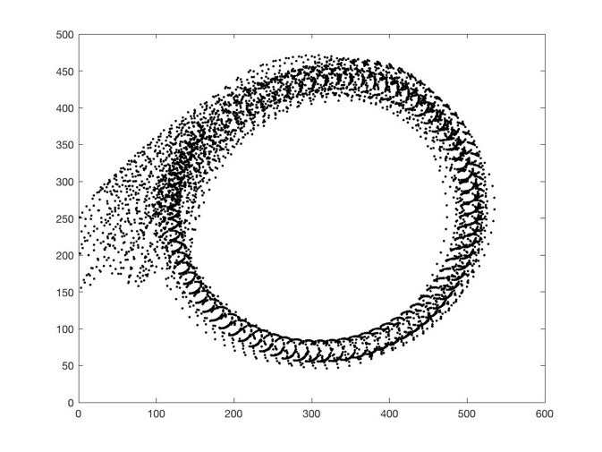

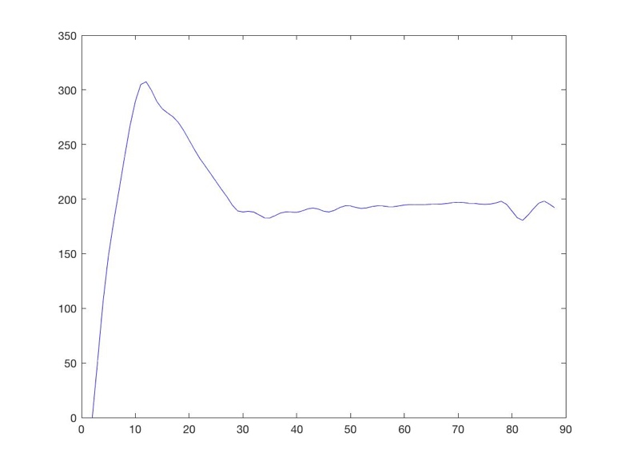

Figure 4.3: The velocities of the nodes

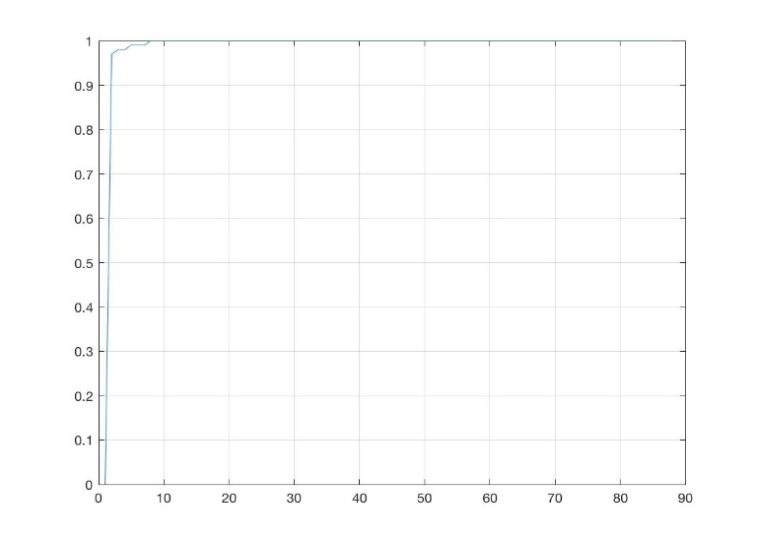

Figure 4.4: The connectivity of the flock